Bilal Chaudhary

Technical Writing

07/03/2020

Many computer science graduates are faced with technical interview questions which require time and problem solving skills. Working through those problems can help build problem solving skills which would make a better programmer, and in this case, give an individual a better chance of getting a competitive programming job. I will give an example of a common programming question and work through the steps of solving it..

*Given a collection of n nuts, and a collection of n bolts, each arranged in an increasing order of size, give an O(n) time algorithm to check if there is a nut and a bolt that have the same size. You can assume that the sizes of the nuts and bolts are stored in the arrays NUTS[1..n] and BOLTS[1..n], respectively, where NUTS[1] < ··· < NUTS[n] and BOLTS[1] < ··· < BOLTS[n]. Note that you only need to report whether or not a match exists; you do not need to report all matches.*

Let us suppose N = [1..n] be the collection of nuts and B[1..n] the collection of bolts.This idea is similar to the Merge procedure in Merge-Sort that merges two sorted lists.We initialize two pointers, and throughout each iteration of the loop we compare Nuts[i] to Bolts[j], and if there’s a match, then we return true; otherwise, we increment the pointers. If the size of Nuts[i] is less than the size of Bolts[j], we increment i. In the other case, if it is larger, we increment j. If we iterate through the entire array, and true is not returned, then no match exists, hence the runtime of O(n^2) would not be possible. Setting aside any constants, we would get O(n).

Step 1: Declare pointers

Step 2: Initialize loop

Step 3: Declare key variable

Step 4: Cycle loop and compare variables

Step 5: Update pointers during loop

Step 6: Once variable matches key variable, halt loop

Step 7: Check and see if the size of N[i] is smaller than B[j], if it is we increment i

Step 8: Check and see if the size of N[i] is equal to or larger than B[j] we increment j

Step 9: If we cycle through loop and find no matches, we must report that no matches were found

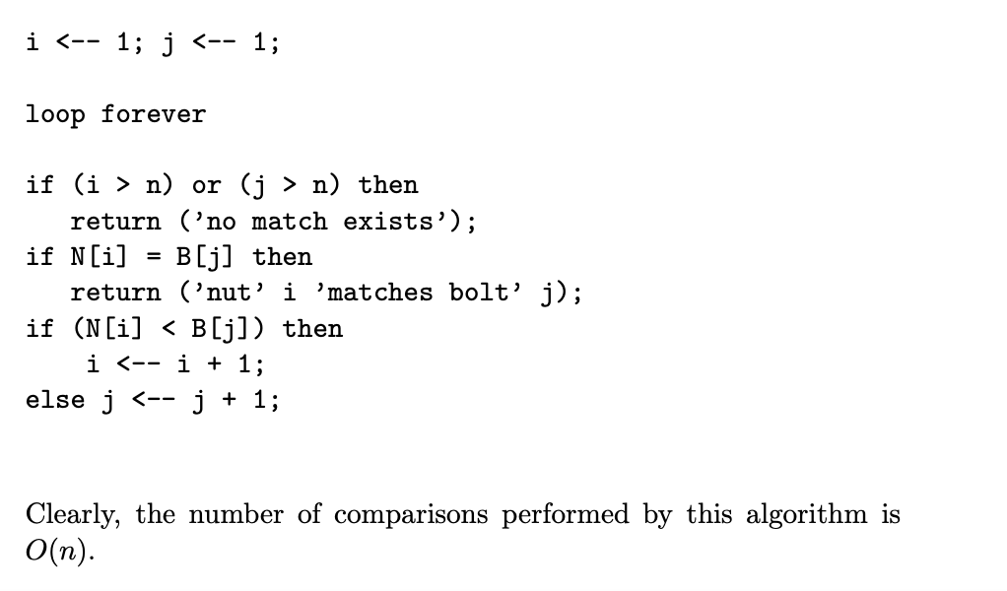

This illustration above represents the pseudocode required to complete this task. It should be noted that the solution is elegant and online there are many crude and makeshift solutions. However, this is the procedure an individual should go through when attempting to answer such a technical interview question.